Assignment 3. Media Queries & Bootstrap Grid.

Team Name: KFC Bosses Group: SE-2510 Topic: KFC Kazakhstan Project

1. Team Members & Roles
- Zharkyn Akhmetov
  - Role: Bootstrap Components & Responsive UI Developer.
  - Pages Created: index.html, menu.html, gallery.html
- Khantore Orynbassar
  - Role: Bootstrap Grid & Layout Developer
  - Pages Created: schedule.html, contacts.html, gallery.html
- Alnur Bakbergenov
  - Role: Responsive Design & Media Queries Developer.
  - Pages Created: promos.html, about.html, gallery.html

2. Objective

The objective of Assignment #3 was to apply CSS Media Queries and the Bootstrap Grid system to create responsive web layouts. The goal was to make web pages automatically adapt to different screen sizes, including mobile, tablet, and desktop, while improving responsiveness, styling, and user experience through Bootstrap’s 12-column grid and components.
3. Step-by-Step Description of Tasks

Part 1: Media Queries
Step 1: Responsive Typography
We created responsive typography for headings and text using custom CSS classes such as ".responsive-heading" and ".responsive-copy". Different font sizes are applied depending on the screen width. On desktop screens, headings use a larger font size, while tablet and mobile screens use smaller sizes. The CSS media queries use breakpoints at 991.98px and 576px to adjust the typography. This allows the text to remain readable and properly scaled on different devices.

Step 2: Responsive Card Group
A separate card group was created on the main page using custom CSS and Media Queries without Bootstrap. The ".media-card-group" uses Flexbox to arrange three cards in one row on large screens. When the screen becomes smaller than 768px, the cards are wrapped so that two cards can appear in one row. On mobile devices below 576px, the cards are displayed vertically in a single column. The three cards contain information about Student Deals, Fresh Meals, and Fast Service.
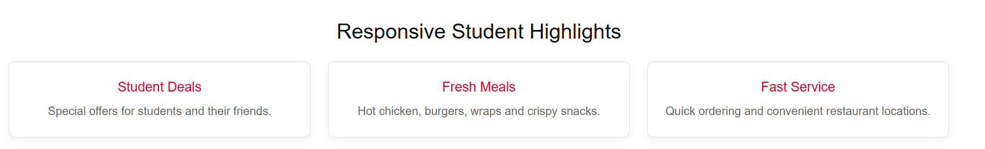
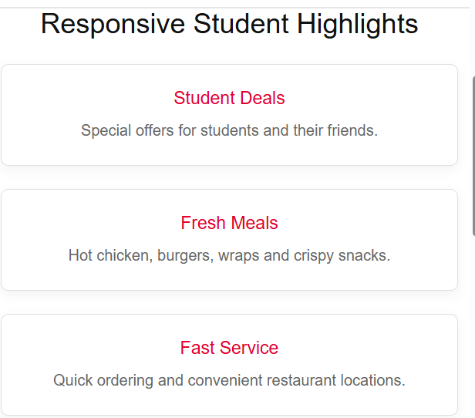

Part 2: Bootstrap
Step 3: Bootstrap Grid Layout
Bootstrap's responsive grid system was implemented throughout the website. On the main page, sections use Bootstrap rows and responsive columns such as "col-md-6" to create two-column layouts. On the promotions and other pages, classes such as "col-sm-6 col-lg-4" are used to create three-column layouts on large screens. The Bootstrap ".container" and ".container-fluid" classes are used to keep the content properly aligned and provide consistent horizontal spacing. The grid automatically changes according to the screen size, allowing the website to remain responsive on desktop, tablet, and mobile devices.
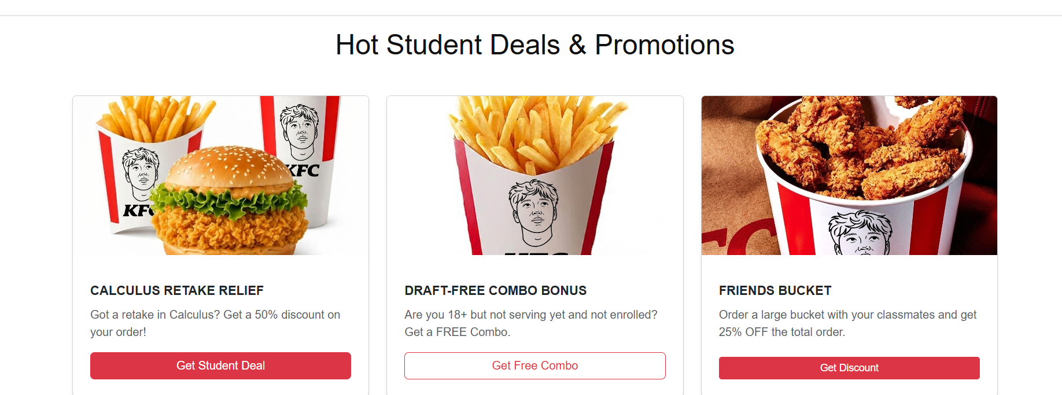
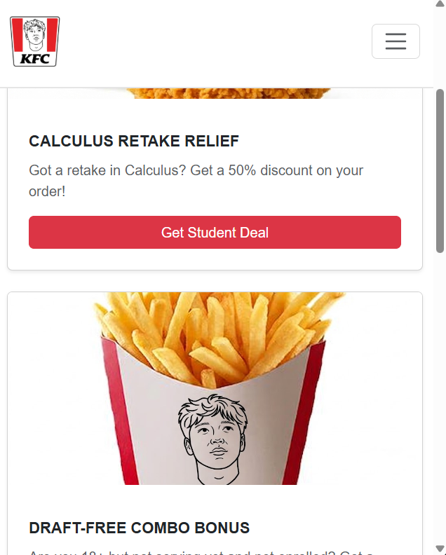
Step 4: Bootstrap Spacing Utilities
Bootstrap spacing utilities were used to replace unnecessary custom spacing in different parts of the website. Classes such as "mt-lg-4", "mb-4", "mb-3", "p-4", "px-sm-2", "g-4", and "mt-5" are used throughout the project. These classes provide consistent margins, padding, and gaps between elements while also allowing spacing to change according to the screen size.
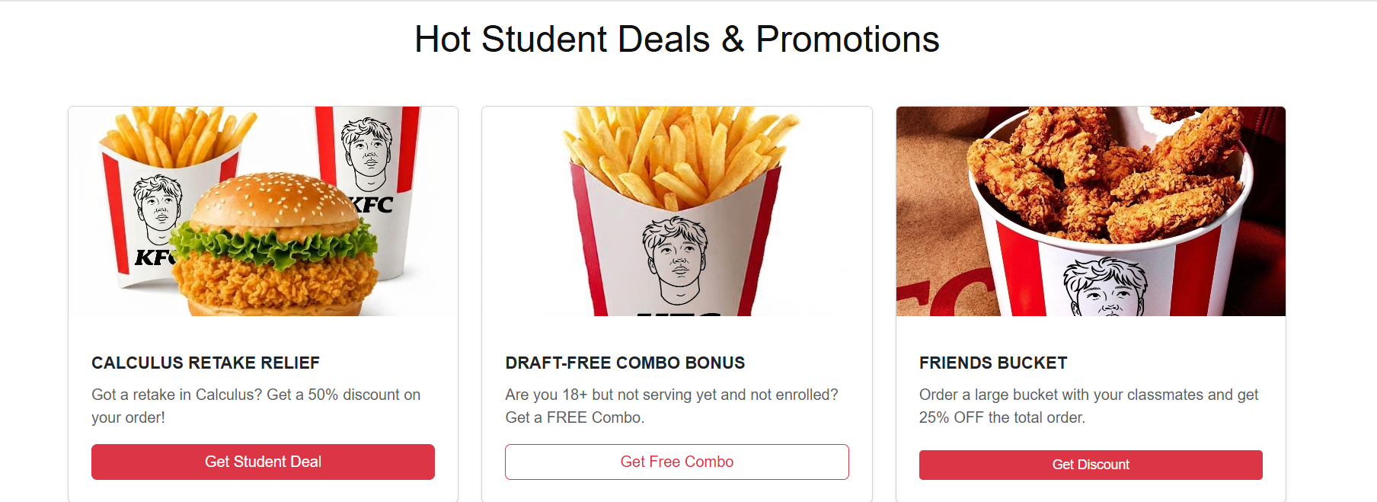
Step 5: Bootstrap Navigation Bar
A responsive Bootstrap navigation bar was implemented across the website. The navigation uses Bootstrap classes such as "navbar", "navbar-expand-lg", "navbar-brand", "navbar-nav", and "nav-link". The navigation contains links to the Main Menu, Food Menu, Special Offers, Our Team, Location & Schedule, Reviews & Feedback, and Gallery pages. For smaller screens, the navigation collapses into a hamburger menu using the "navbar-toggler" and Bootstrap's collapse functionality. The navigation bar was additionally customized using CSS to match the KFC-style design, including the logo, active link, colors, spacing, and hover effects.
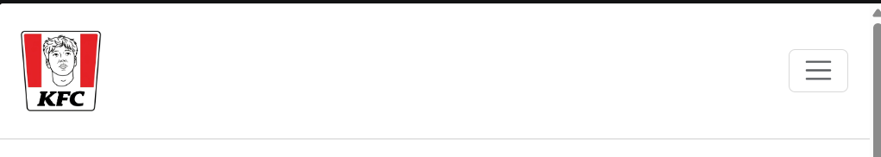
Step 6: Bootstrap Buttons
Custom buttons were replaced and supplemented with Bootstrap button classes.The project uses classes such as "btn", "btn-danger", "btn-outline-danger", "btn-lg", and "btn-sm". Different button sizes and styles are used depending on their purpose. For example, the main page contains large action buttons, while promotion cards use different button styles and sizes. A Bootstrap "btn-group" was also implemented on the Gallery page to group related navigation actions together.
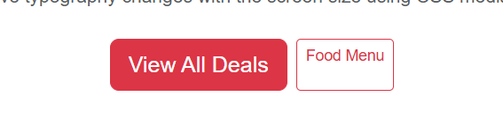
Step 7: Bootstrap Carousel
A Bootstrap carousel was implemented on the Gallery page.The carousel contains nine different images and includes navigation indicators, previous/next controls, and captions.Bootstrap classes such as "carousel", "carousel-inner", "carousel-item", "carousel-indicators", "carousel-control-prev", and "carousel-control-next" were used.The carousel is responsive and its image height changes on smaller screens through CSS Media Queries
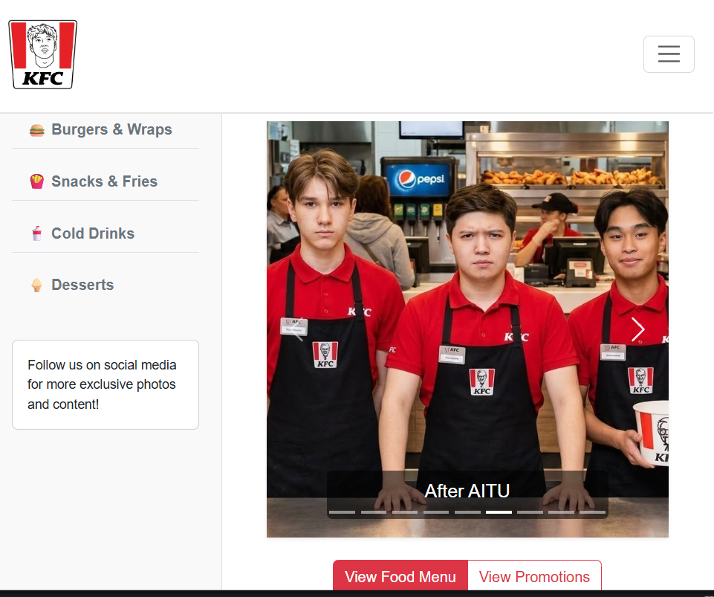
Step 8: Bootstrap Cards
Bootstrap cards were implemented throughout the project.The Promotions page contains three Bootstrap cards with images, titles, descriptions, and action buttons. The Food Menu page also uses Bootstrap cards for individual dishes. Bootstrap classes such as "card", "card-body", "card-title", "card-text", "shadow-sm", and "h-100" were used to create a consistent card structure. The promotion images use the custom ".promo-card-image" class with "object-fit: cover" to keep the images visually consistent.s.
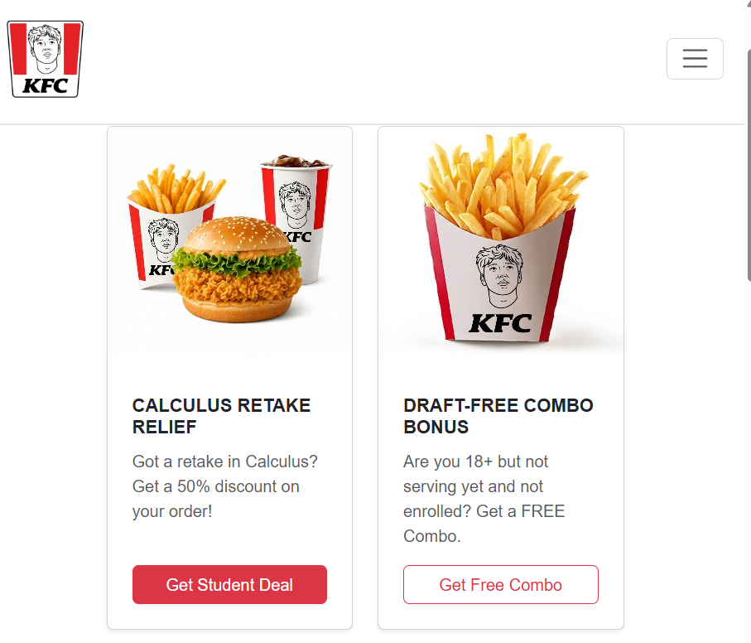
Step 9: Responsive Form Design
A responsive customer feedback form was implemented on the Reviews & Feedback page. Bootstrap form classes such as "form-label", "form-control", and "form-select" are used for the name, email, rating, and review fields. The form is placed inside a Bootstrap grid and card layout. The page uses responsive columns so that the feedback form and recent reviews section adjust automatically according to the available screen width. The submit button uses Bootstrap classes including "btn", "btn-danger", "w-100", and "btn-lg".
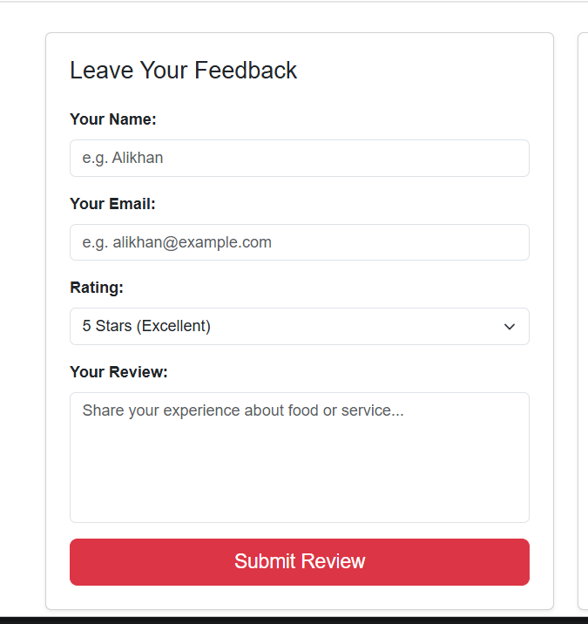
Step 10: Accessibility
Accessibility was considered while implementing the Bootstrap components. Semantic HTML elements such as "<nav>", "<main>", "<section>", "<article>", "<button>", and "<footer>" are used throughout the website. The navigation button contains an "aria-label", while the navigation and carousel also use appropriate ARIA attributes. Images include descriptive "alt" text. The form fields use labels connected to their inputs, and the carousel contains accessible labels for its controls and slides. The project also maintains readable contrast between text and backgrounds, while Bootstrap components provide consistent and recognizable interface elements.
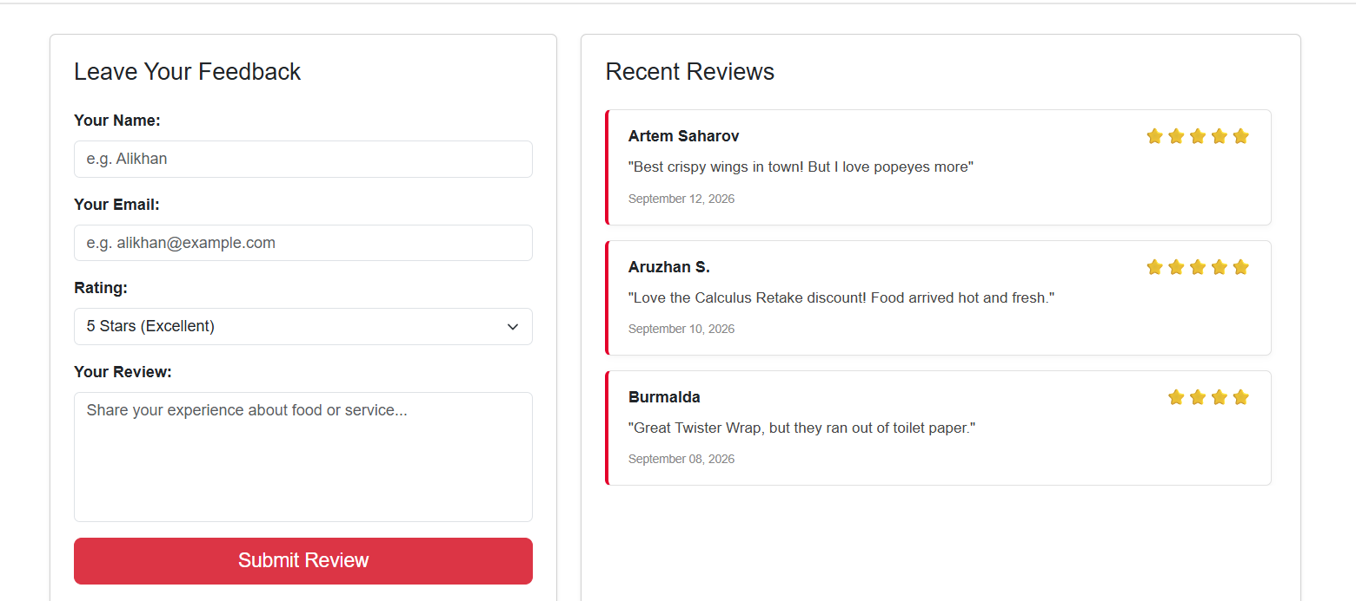

Part 3: Publishing Responsive Website
GitHub Pages / Netlify URL: https://github.com/Alnur07/WEB-3-Assignment.git

